STANDARD WHI.5c
The student will demonstrate knowledge of ancient Greece in terms of its impact on Western civilization by
c) identifying the social structure and role of slavery, explaining the significance of citizenship and the development of democracy, and comparing the city-states of Athens and Sparta.

Essential Understandings

- Classical Athens developed the most democratic system of government the world had ever seen, although not everyone could participate in decision making. It became a foundation of modern democracies.

- Contrasting philosophies of government divided the Greek city-states of Athens (democracy) and Sparta (oligarchy).

Essential Knowledge
Social structure and citizenship in the Greek polis
- Citizens (free adult males) had political rights and the responsibility of civic participation in government.
- Women and foreigners had no political rights.
- Slaves had no political rights.

Athens
Sparta
- Oligarchy (rule by a small group)
- Rigid social structure
- Militaristic and aggressive society
- Stages in the evolution of Athenian government: Monarchy, aristocracy, tyranny, democracy
- Tyrants who worked for reform: Draco, Solon
- Origin of democratic principles: Direct democracy, public debate, duties of the citizen

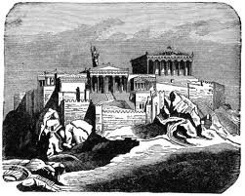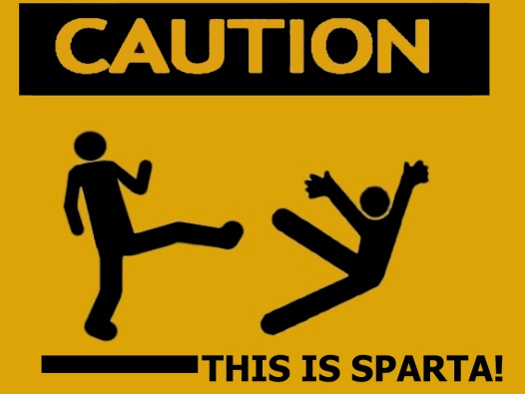

STANDARD WHI.5c
The student will demonstrate knowledge of ancient Greece in terms of its impact on Western civilization by
c) identifying the social structure and role of slavery, explaining the significance of citizenship and the development of democracy, and comparing the city-states of Athens and Sparta.

Essential Understandings

- Classical ______________ developed the most ______________ system of government the world had ever seen, although not everyone could participate in decision making. It became a foundation of modern democracies.

- Contrasting ______________ of government divided the Greek city-states of ______________ (democracy) and ______________ (oligarchy).

Essential Knowledge
Social structure and citizenship in the Greek polis
- ____________ (free adult males) had political rights & the responsibility of civic participation in government.
- ___________ & _____________had no political rights.
- ____________had no political rights.

Athens
Sparta
- __________ (rule by a small group)
- _____________social structure
- _____________ and _____________ society
- Stages in the evolution of Athenian government: __________, ___________, __________, __________
- Tyrants who worked for reform: ________, ________
- Origin of democratic principles: Direct ________, public ________, duties of the ________

